Enable SSH esxi

https://www.virtubytes.com/2017/04/21/enable-ssh-vmware-esxi-6-5/

From the home page, select **Host** and navigate to the **Actions** gear. From the **Actions** menu select **Services**, and choose **Enable Secure Shell**.

[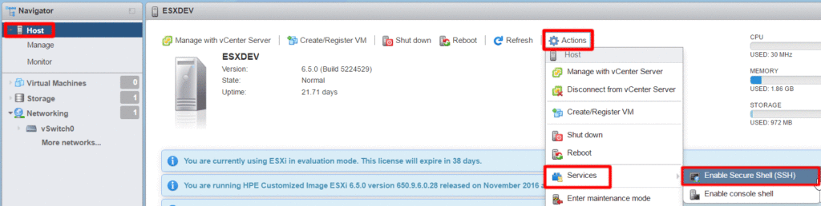](https://www.virtubytes.com/wp-content/uploads/2017/04/Host_SSH.gif)

Additionally, SSH can also be enabled from the **Services** tab under **Manage**. Simply select **SSH** and **Start** from the **Actions** gear.

[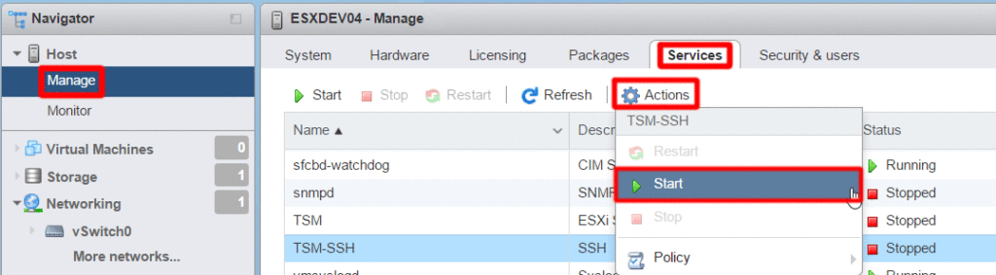](https://www.virtubytes.com/wp-content/uploads/2017/04/Host_SSH_Start.gif)

Enable SSH | vSphere Web Client – vCenter

Log into the vCenter instance via the web client.

[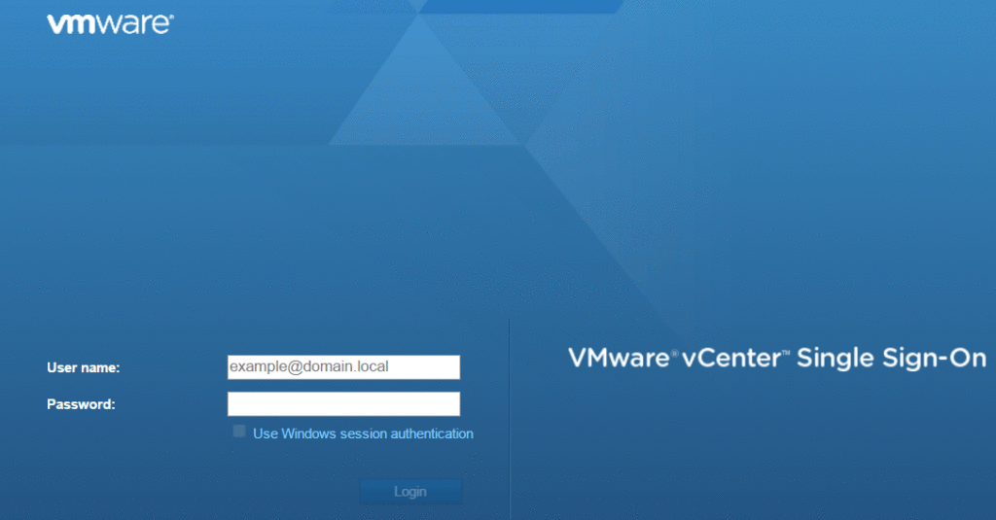](https://www.virtubytes.com/wp-content/uploads/2017/04/vCenter_Login.gif)

Select the pertinent host, navigate to the **Configure** tab. Scroll down to the **System** section, and select **Security Profile**.

[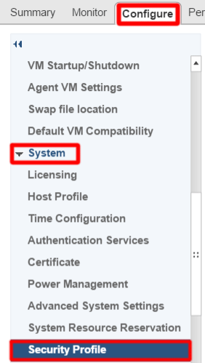](https://www.virtubytes.com/wp-content/uploads/2017/04/vCenter_Security_Profile.gif)

Scroll down to the **Services** section and click **Edit**.

[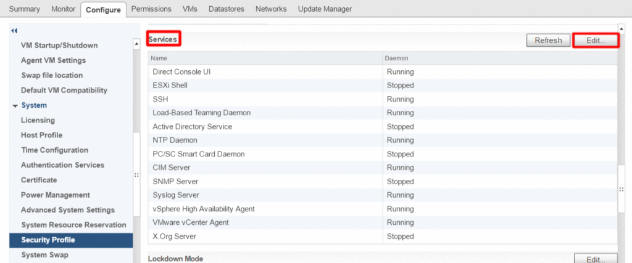](https://www.virtubytes.com/wp-content/uploads/2017/04/vCenter_Services.gif)

Locate the **SSH** service and select **Start**.

[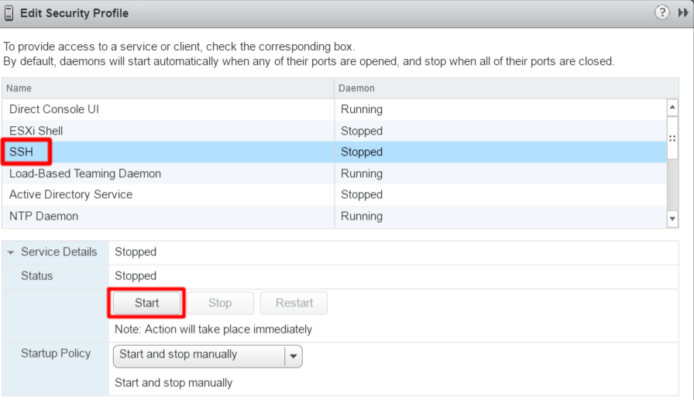](https://www.virtubytes.com/wp-content/uploads/2017/04/vCenter_SSH.gif)

You can now access your ESXi host remotely via a Secure Shell client. Lastly, it is always wise to Stop/Disable SSH once you are done.

https://support.auvik.com/hc/en-us/articles/206311526-How-to-enable-SNMP-on-a-VMware-ESXi-hypervisor

How to enable SNMP on ESXi 6.x

1. SSH or Telnet to your ESXi node using root-level credentials.
2. Execute the following commands. Replace *YOUR_STRING*with your desired community string.

esxcli system snmp set -r  
esxcli system snmp set -c YOUR_STRING  
esxcli system snmp set -p 161  
esxcli system snmp set -L "City, State, Country"  
esxcli system snmp set -C [noc@example.com](mailto:noc@example.com)esxcli system snmp set -e yes

1. If you selected a community string other than public or private, enter that string into Auvik by following [these steps](https://support.auvik.com/hc/en-us/articles/204565824-#topic_add).
2. If in Step 2 you chose to “Apply these credentials to all devices we discover that meet the criteria below” ensure that:
   1. Device Type = All Device Types
   2. Vendor = All Vendors

You’re all done! Your VMware hypervisors will now be discovered by Auvik. If you haven’t already done so, you should now [add your VMware credentials](https://support.auvik.com/hc/en-us/articles/205932850-#topic_add) for your VMware hypervisors and hosts.

My settings

esxcli system snmp set -r

esxcli system snmp set -c contoso01

esxcli system snmp set -p 161

esxcli system snmp set -L "Portsmouth, Virginia, US"

esxcli system snmp set -C kevin.f.flowers@contoso01.com

esxcli system snmp set -e yes